Disposable Wisdom Teeth Used to Restore Eyesight in Cornea Study
By Revathi Siva Kumar(writer@newseveryday.com) - 25 Feb '15 17:03PM
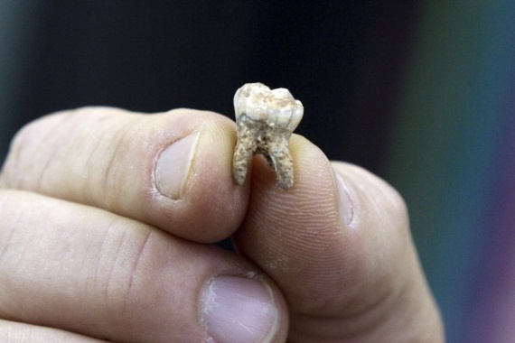
- (Photo : JACK GUEZ/AFP/Getty Images) Professor Avi Gopher, of Tel Aviv University's Institute of Archaeology, shows ancient teeth that were discovered at an archaeological site near Rosh Haain in central Israel, on December 29, 2010.
So it's an eye for a tooth and a tooth for an eye, if you go by new research. Your wisdom tooth holds the key for treating blinding illnesses that may affect the eye's cornea. Any illness that impacts the cornea could be a major cause of blindness worldwide.
"Stem cells from the dental pulp of wisdom teeth can be coaxed to turn into cells of the eye's cornea and could one day be used to treat corneal blindness," said the researchers, according to indianexpress.com.
Evidence from research show that a wisdom tooth could be the new source of corneal transplant tissue from the patient's own cells. "Corneal blindness, which affects millions of people worldwide, is typically treated with transplants of donor corneas," explained senior investigator James Funderburgh, professor of ophthalmology at the University of Pittsburgh School of Medicine.
"Shortages of donor's cornea and rejection of donor's tissue do occur, which might result in permanent blindness. Our work is promising because using the patient's own cells for treatment could help us avoid these problems," said Funderburgh.
The researchers showed that stem cells of the dental pulp, that could be taken from the regular third molar, or wisdom tooth, could in turn transform into corneal stromal cells that are named keratocytes. These engineered keratocytes were injected into the corneas of healthy mice, in which they became part of the receptors, with no rejection. The cells were used to create constructs of corneal stroms, which was rather like natural tissue.
"Other research has shown that dental pulp stem cells can be used to make neural, bone and other cells," Dr. Syed-Picard noted. "They have great potential for use in regenerative therapies."
The scientists have also planned out some future work, in which they will assess whether the technique can correct corneal scarring in an animal model, according to sciencedaily.com.
The study was published in the journal, 'STEM CELLS Translational Medicine'.

